**Exercise 1: Setting Up Junit**

1. Create a new Maven project.

2. Add JUnit dependency to your project i.e., we need to add a dependency in pom.xml:

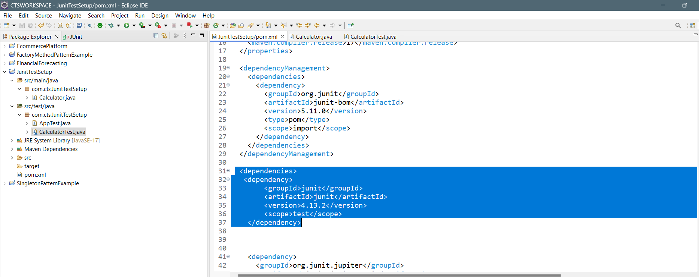

3. Create a new test class in your project.

**Calculator.java:**

**package** com.cts.JunitTestSetup;

**public** **class** Calculator {

**public** **int** add(**int** a, **int** b) {

**return** a + b;

}

}

**CalculatorTest.java:**

package com.cts.JunitTestSetup;

import static org.junit.jupiter.api.Assertions.*;

import org.junit.jupiter.api.Test;

class CalculatorTest {

@Test

public void testAdd() {

Calculator calc = new Calculator();

assertEquals(5, calc.add(2, 3));

}

}

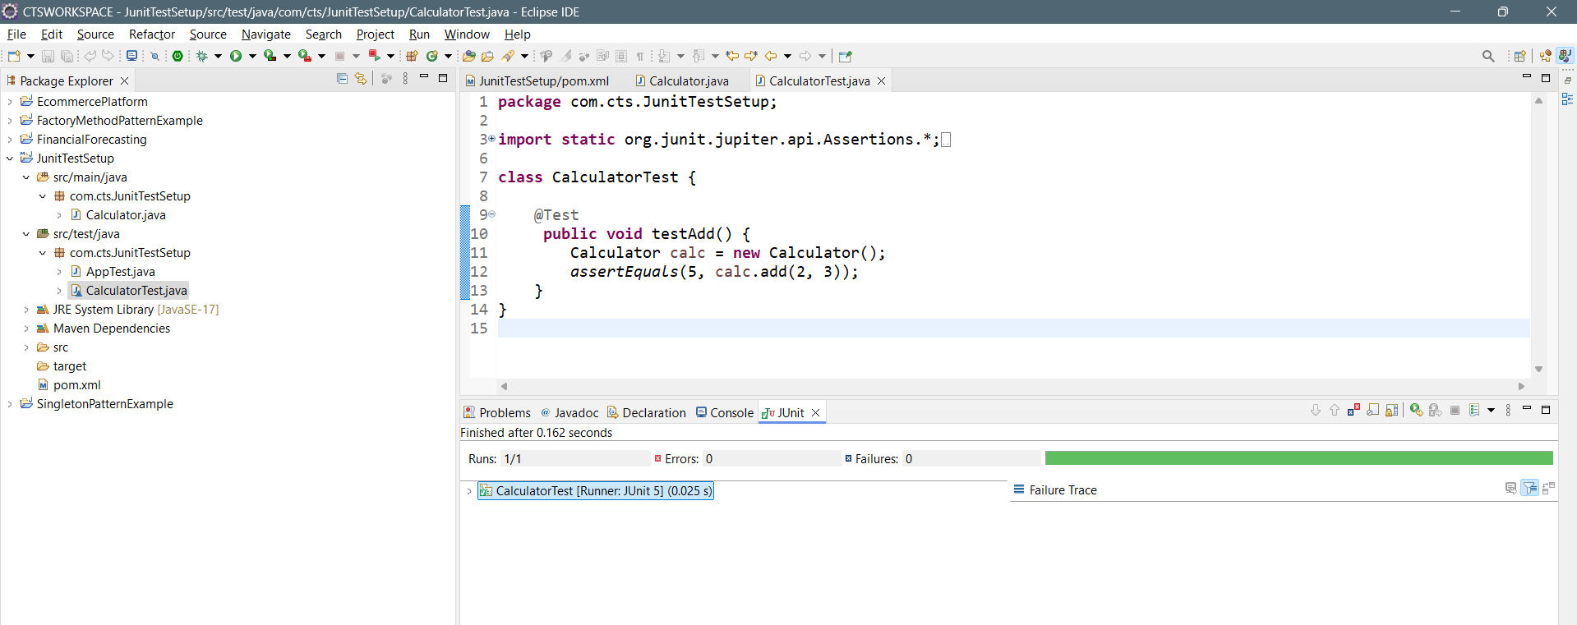**Output:**

Project Structure:

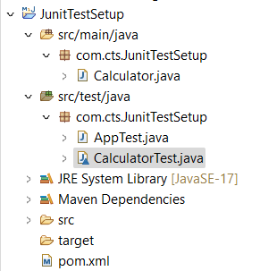

Fail Test Case: